MARKET SECTOR ACTIVITY
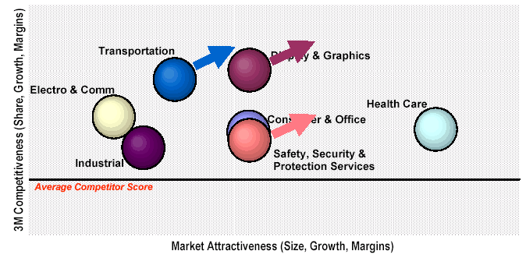


(For internal use only: 3M have awarded a contract for economy grade cloth to Empire Tapes - it is expected that this deal will supply 3M with economy cloth tape in the UK and possibly Europe)

